Southwest Corner of I-14 and FM 1670 Belton, Texas

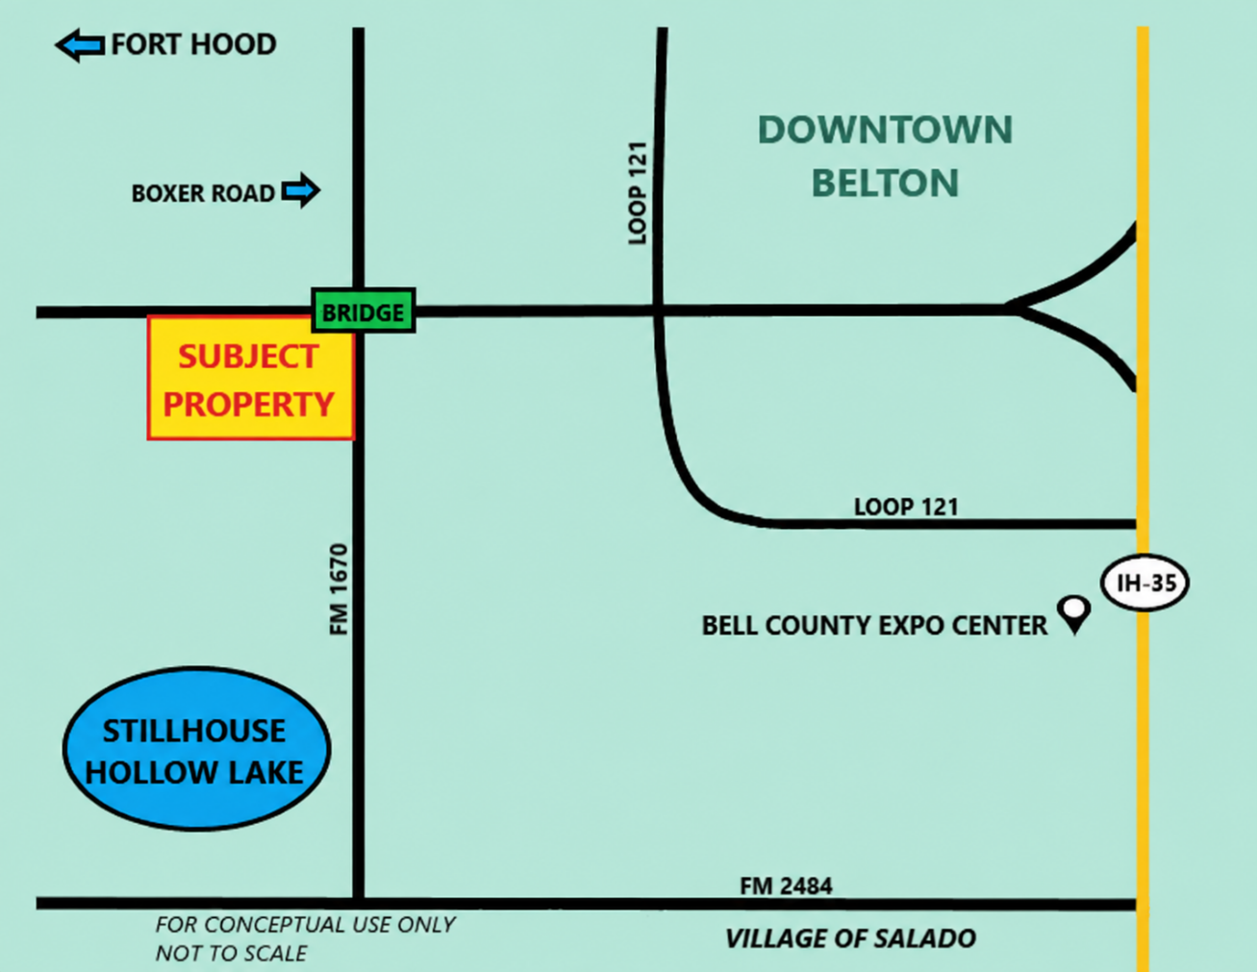

Ideal Location for Quick Service Restaurants And Other Convenience Oriented Retail Users

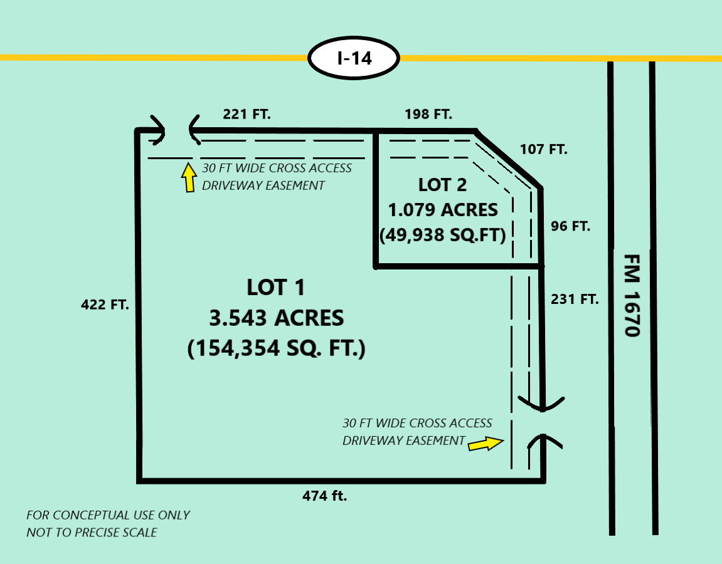

Lot 1: | 3.543 Acres (154,333 Sq. ft.)  Potentially may be re-subdivided into two or more smaller lots to meet the needs of appropriate businesses
Water: | The City of Belton working with the Dog Ridge Water Supply Corporation is in the process of constructing a new 10 inch water line that will provide public water service and fire flow protection for future businesses on the subject property
Sewer: | The City of Belton is in the process of constructing a new 8 inch sewer line that will provide public sewer service for future businesses on the subject property
Zoning: | The subject property is currently zoned Retail by the City of Belton
Cross Access Driveway Easements: | Recorded Cross Access Driveway Easements are currently in place to provide access from all lots to future driveway cuts on both I-14 and FM 1670
Asking Price: | $12.00 per sq. ft.
Restrictions on future uses: | The subject property is currently deed restricted against future use as a convenience store, gasoline station, and certain other uses.
Lot 2: | 1.078 Acres (46,938 Sq. ft.) was recently sold and is now owned by a different group, but potentially may be available for purchase by an appropriate non convenience store business

For Additional Information
Please Contact:

Real Estate Broker for Seller:



Mike Elliott
Tel: (512) 452-2553
Mike@ElliottPropertiesInc.com
www.ElliottPropertiesInc.com

Elliott Properties makes no representations or warranties expressed or implied, as to the accuracy of this
information. This offering is made subject to errors, omissions, changes in price or withdrawal without notice.

